Character Dropper

The CharacterDropper tool is used to add animated characters into an existing Unity environment at runtime. These characters are meant to bring more immersion into the scene and to allow the user to get a sense of how real people will move around the environment. These characters are designed to be configurable to allow the user to simulate different real-world scenarios and behaviors.

The tool loads character models from the Resources/Characters folder in the Unity project. These models are then shown as options when the user is dropping a new character into the scene. The characters that are dropped can be set to different modes depending on the desired behavior. These modes include Idle, where the character stays at the point it was dropped, Patrol, where the character wanders to random points within a radius around a center point, and Explore, where the character can wander anywhere that they can walk to in the scene.

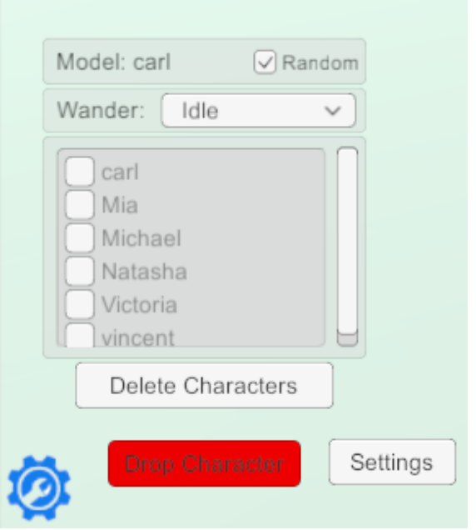

To drop a character, click on the gear icon in the lower left corner. This opens the main menu. Clicking on the Drop Character button at the bottom of the screen will then start the Character Dropper tool and open the menu showed above. When the tool first opens, it will be set to drop a random character in Idle mode. By clicking any of the check boxes next to a model name, the model of character is dropped can be changed. Clicking the Wander drop down will show the other options for modes, Patrol and Explore. While the tool is open, a temporary character will show where the character will drop as you move the mouse around. Left clicking will place the temporary character and make them permanent in the scene. If the Patrol mode is selected, the user can then set the radius that the character should patrol in. This is done by moving the mouse cursor until the colored circle shown on the ground covers the desired patrol area. Once this has been completed the tool will show a new temporary character. This process can be repeated multiple times to add a variety of characters to the scene.

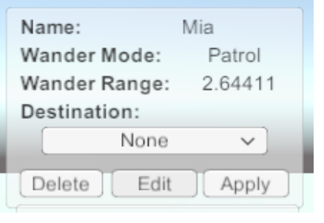

After a character is dropped, they can be clicked on to open the menu shown above. This menu displays all of the characters settings and also gives the option to send the character to a destination. When clicking on the destination dropdown, a list of POIs in the current scene will be displayed as options. Selecting one of these and clicking apply will start the character moving towards the desired destination. Clicking Delete will remove the selected character from the scene. The Edit button opens the window shown below.

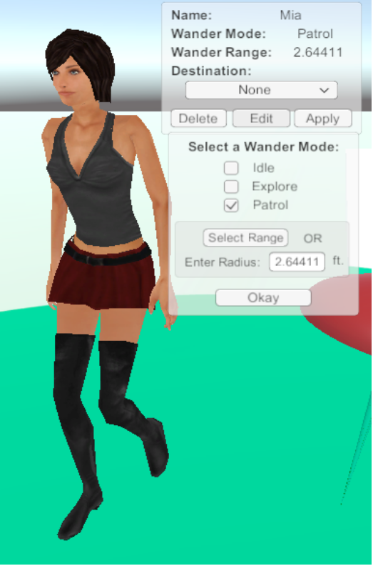

From here, their mode can be changed by selecting a new mode in the bottom panel. When Patrol is selected, the lower portion of the bottom menu will be shown and a radius can be given for the patrol area. There are two ways to set the radius, either by clicking Select Range and then clicking on the ground when the displayed circle matches the desired patrol area, or input a numerical radius in the input box shown. When the user is finished setting the Wander Mode, they can click the Okay button to go back to the information panel, and then click Apply to accept all of their changes.

